How to include the "edit" button next to bibliographic records in the repository search | 

Yoel Kortick
Senior Librarian

There may be catalogers who often search the repository for bibliographic records and then wish to edit the records. If this is the case then it may be "too many clicks" to first click the record from repository search, arrive to the "Record View" page, and then click "Edit".

In one simple step it is possible to configure the Alma repository search to have the "Edit" button next to each record in the repository search results.

Here are the steps

ONE
Note that cataloger Madeline Matar has searched the repository via an "all titles" search for title "Parcours de femmes : twenty years of women in French". If she wants to edit this record she first needs to click the records, arrive to the "Record View" page, and then click "Edit".

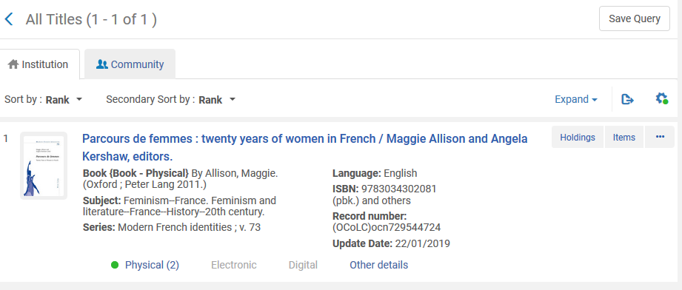

TWO
Click the configuration wheel (cog) on the top right

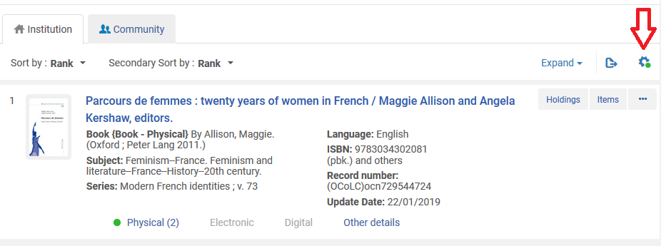

THREE

You will arrive to the configuration view. On the top right of the configuration view you will see a section for the buttons.
Click "Show all" in the bottom center

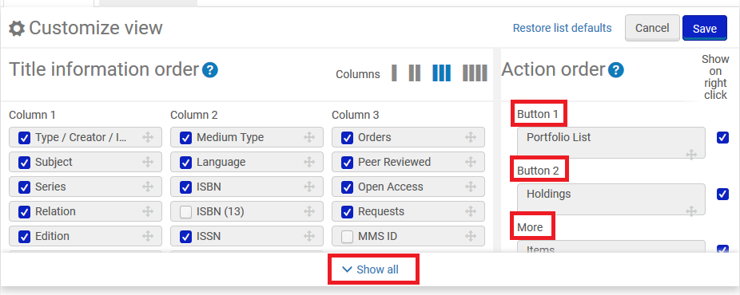

FOUR

Activate and drag the "Edit Record" button to the top. Put it in the "Button 1" or "Button 2" section.
Here is before and after

Before | After
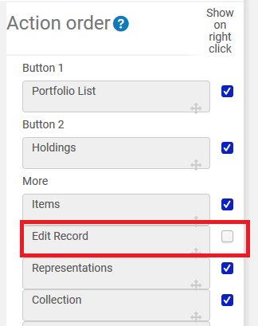 | 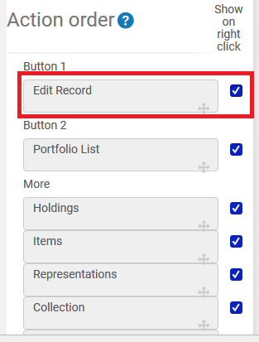

FIVE

Save the configuration

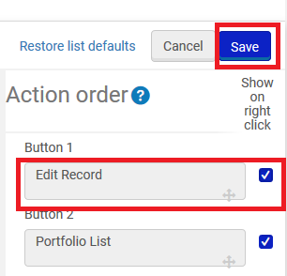

SIX

Now do a search and see the button right next to record in repository search results.
Note that this configuration is per user and not per institution. Each user can have their own configuration.

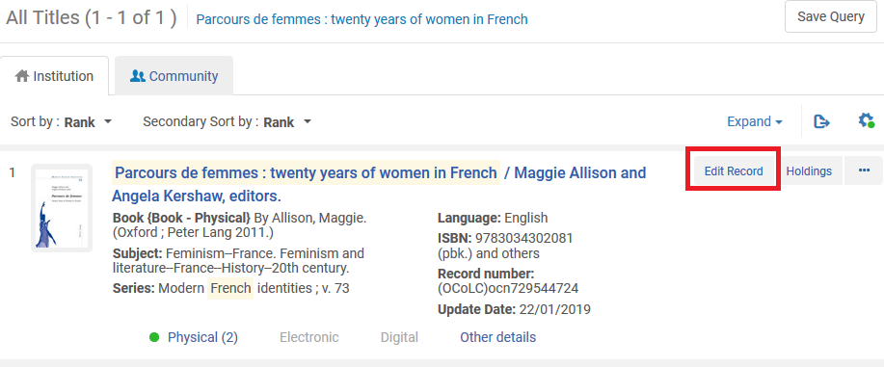

SEVEN

Now when you click the "Edit Record" button the record immediately opens in the metadata editor. No need to first have the "Record View".

